

**PROGRAMME TITLE: EBRD UNCITRAL Public Procurement Reform Initiative**

**PROJECT TITLE: Moldova: Assistance with Piloting Electronic Framework Agreements on MTender**

***Deliverable 2: workplan ID: P4-T2-A1-M2 Blueprint for conclusion of Framework Agreements***

***November 2020***

**APPROVAL PAGE**

October 2020

This document for “Blueprint for conclusion of FA” of the project “Moldova: Policy advice, legislative drafting and on-going support to the MTender Pilot in 2020” was first prepared as a draft and submitted on the 15th October 2020 by the Consultant: everis and uStudio. It has gone through a number of iterations, and this version 1.0 is the final version. The document has been examined by the EBRD OL and the representatives of the Government Client/Beneficiaries of Republic of Moldova and is hereby recommended for approval and acceptance.

|  |  |
| --- | --- |
| **Client/beneficiary Name** | **Ministry of Finance of the Republic of Moldova** |
| **Project title** | **Moldova: Policy advice, legislative drafting and on-going support to the MTender Pilot in 2020** |
| **Date of scheduled delivery** | 09/10/2020 |
| **Date of submission for acceptance** | 15/10/2020 |

|  |  |  |
| --- | --- | --- |
| **The output is specified in the table below and includes a list of delivered deliverables. The output is in accordance with approved specifications and complies with all conditions defined in the Contract, as per the Terms of Reference.** | | |
| **Deliverable** | **Deliverable Description** | **Acceptance Date** |
| 2 | *P4-T2-A1-M2 Blueprint for conclusion of FA* |  |
| **All deliverables were prepared in required quality and time and are accepted without open points.**  **Other comments [….]** | | |

|  |  |  |
| --- | --- | --- |
| **Consultancy & Report Author** | Signature: | Date: |
| **Everis Spain, SLU** |
| **Persons authorised to Sign-off** | Signature: | Date: |
| **Eliza Niewiadomska, EBRD OL** |

*Please be advised that the report has been prepared exclusively for EBRD. EBRD makes no representation or warranty, express or implied, as to the accuracy or completeness of the information set forth in this report. EBRD has not independently verified any of the information contained in the report and EBRD accepts no liability whatsoever for any of the information contained in the report or for any misstatement or omission therein. The report remains EBRD’s property*

**DOCUMENT CHARACTERISTICS**

|  |  |
| --- | --- |
| **Property** | **Value Proposition** |
| Release date | *15/10/2020* |
| Status: | For review/approval/final |
| Version: | *1.0* |
| Authors: | *uStudio, everis* |
| Reviewed by: |  |
| Approved by: |  |

**DOCUMENT HISTORY**

|  |  |  |
| --- | --- | --- |
| **Version** | **Description** | **Date** |
| 1.0 | *First version of the document*  *<https://my.huddle.net/workspace/33889435/files/#/83253270>*  *https://app.breeze.pm/projects/140893/cards/3533227* | *25/11/2020* |
| 2.0 |  |  |
| 3.0 |  |  |
| 4.0 |  |  |
| 5.0 |  |  |

Table of Contents

1. Introduction 7

1.1 Aim of the document 7

1.2 Alignment with regulation 7

2. Technical design 8

2.1 Basic concept of a FA with the participation of a CPB 8

2.1.1 Main data blocks 8

2.1.2 Main actors 10

2.1.3 Data flow 10

2.2 BPMN 11

2.3 OCDS design 11

2.3.1 Map of relations 13

2.3.2 OCDS parallel records used to reflect OCDS design for FAs 14

2.4 OCDS blocks involved in the conclusion of a FA 19

2.5 Building components 20

2.5.1 Initiation of a FA 20

2.5.2 Aggregated planning 21

2.5.3 Design of a FA 22

2.5.4 Conclusion of a FA 33

2.5.5 Pre-award catalogue request 46

**LIST OF FIGURES**

Figure 1 - Basic diagram of a FA with the participation of a CPB 8

Figure 2 – BPMN for the general process of a FA 11

Figure 3 – OCDS design for a FA 12

Figure 4 - BPMN for initiation of a FA 21

Figure 5 - BPMN for aggregated planning 21

Figure 5 – Component diagram for aggregated planning 22

Figure 7 – State-chart diagram for the conclusion of a FA 33

Figure 8 – State-chart diagram for submission of EoIs 36

Figure 9 – State-chart diagram for Qualification 39

Figure 8 – State-chart diagram for a PAC request 47

**LIST OF TABLES**

Table 1 – Main data blocks involved in a FA 9

Table 2 – Main actors involved in a FA 10

Table 3 – Main actors involved in a FA 11

Table 4 – Map of relations 14

Table 5 – Attributes of EI 14

Table 6 – Attributes of FS 14

Table 7 – Attributes of CP 15

Table 8 – Attributes of PN 16

Table 9 – Attributes of MC 17

Table 10 – Attributes of EI 17

Table 11 – Attributes of FA 18

Table 12 – Attributes of AP 18

Table 13 – Attributes of FE 18

Table 14 – Attributes of PQ 19

Table 15 – Attributes of PQC 19

Table 16 – Attributes of PaC 19

Table 17 - OCDS blocks involved in the conclusion of a FA 20

**ABBREVIATIONS**

|  |  |
| --- | --- |
| **Term** | **Description** |
| BPMN | Business Process Model Notation |
| AP | Aggregated Plan |
| CA | Contracting Authority |
| CAN | Contract Award Notice |
| CN | Contract Notice |
| CPB | Central Purchasing Body |
| EBRD | European Bank for Reconstruction and Development |
| EI | Expenditure Item |
| EO | Economic Operator |
| EoI | Expression of Interest |
| FA | Framework Agreement |
| FS | Funding Source |
| MC | Mini Competition |
| MEAT | Most Economically Advantageous Tender |
| NEPP | Networking Electronic Procurement Platform |
| OCDS | Open Contracting Data Standard |
| PAC | Pre-Award Catalogue |
| PC | Purchase Contract |
| PCR | Pre-award Catalogue Request |
| PN | Periodic Notice |

**GLOSSARY:**

|  |  |
| --- | --- |
| **Term** | **Description** |
| MTender | MTender is an end-to-end eProcurement system implemented in Moldova that aims at covering the full public procurement cycle. It is based on a multi‑platform networking digital procurement model, comprising a government‑operated web portal and the Open Data central database unit, which is networking with several commercial electronic platforms certified to support electronic tendering procedures for public sector and commercial clients. |

# Introduction

In the context of a transition to digital public procurement in the Republic of Moldova, a new electronic procurement system was developed and implemented with the European Bank for Reconstruction and Development (EBRD) support.

The phase 4 of the project is focused on electronic Framework Agreement (FA), covering both the conclusion of the FA and the subsequent purchases under a FA using the different types of contracts based on a FA (direct purchase, second-stage competition, etc.), and enabling the participation of Central Purchasing Bodies (CPB) with a specific role in the process.

The use of FA will:

* Enhance value for money and achieve cost savings by aggregating demand and getting better value for money through economies of scale;
* reduce administrative burden by lowering the number of procedures a Contracting Authority (CA) has to run and, therefore, decreasing the time and costs linked to carrying out procurement. The diminished administrative burden also applies to Economic Operators (EO) that are either awarded a contract directly or face a simplified “mini competition” within the FA;
* enable CAs to effectively manage procurement when they cannot objectively foresee the exact type and/or amount of supplies, services and works for a forthcoming period.

## Aim of the document

The main purpose of this document is to provide a detailed technical design in order for the Networking Electronic Procurement Platforms (NEPPs) to be able to implement all the necessary processes and functionalities related to the conclusion of FAs in their platforms.

Purchases under FA will be described in a separate document.

## Alignment with regulation

This blueprint is aligned with:

* Regulation on procurements conducted through framework agreements[1]
* The following standard bidding document:

# Technical design



## Basic concept of a FA with the participation of a CPB

The diagram below shows a basic representation of the interaction between the main actors and data-blocks involved in a FA:

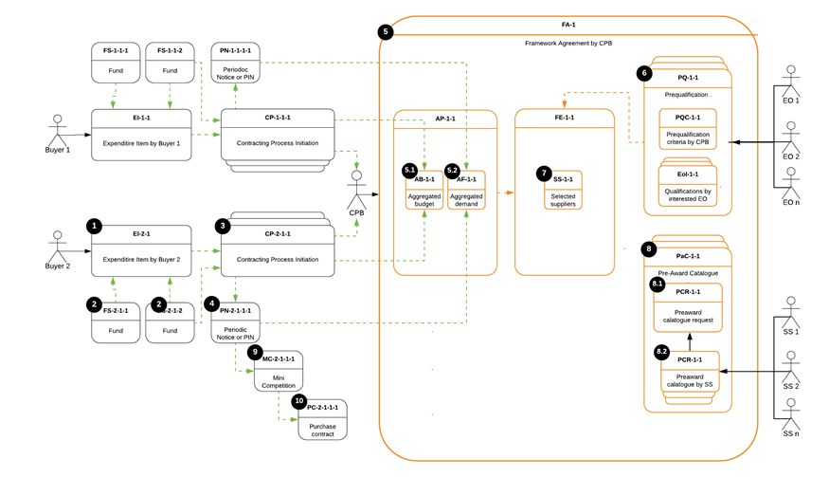

Figure 1 - Basic diagram of a FA with the participation of a CPB[2]

### Main data blocks

|  |  |  |
| --- | --- | --- |
| **Data block** | **Acronym** | **Description** |
| Expenditure Item | EI | Describes a group of goods, services or works determined by specifying the parent CPV code that the CA intends to procure over a certain period, as well as the amount allocated by the CA to finance the purchases under this procurement procedure during the specified period. |
| Funding Source | FS | Describes a specific source of funds for the need from a primary EI. Contains information on both the amount and the organization that provides the funds, as well as on the parties involved in the disposal of these funds such as payer/donor. |
| Contracting Process | CP | Describes a process, so it does not match with an OCDS block. However, it is needed in the FA data model in order to store all the planning and tender information, and its relationship with other processes. |
| Periodic Notice | PN | Describes an announcement of the CA’s intention to conduct a procurement procedure (Aggregation demand notice). |
| Aggregated Plan | AP | Describes both aggregated demand and budget as per CPB analysis. |
| Framework Agreement | FA | Describes a specific instance of a FA initiated by a CPB. |
| Framework Establishment | FE | Describes the conclusion of a FA. |
| Aggregated Budget | AB | Describes the aggregated budget and its breakdown from all the CA, from which planned and requested demand is aggregated within this FA. |
| Aggregated Forecast | AF | Describes an aggregate forecast and its breakdown from all the CA, from which planned and requested demand is aggregated within this FA |
| Pre-qualification | PQ | Describes the pre-qualification phase(s) performed by the CPB for the conclusion of this FA. |
| Pre-qualification Criteria | PQC | Describes a set of exclusion and selection criteria, together with a scoring function (if applicable), as per CPBs' strategy. |
| Expression of Interest | EoI | Describes an interest expressed by an EO via submission of self-declaration to be qualified by the CPB. |
| Selected Suppliers | SS | Describes a list of EOs qualified by the CPB and included into this FA as parties. |
| Pre-award Catalogue Request | PCR | Describes a structured request for electronic catalogue with specific categories of goods or services for this FA provided by the CPB to the selected EOs. |
| Pre-award Catalogue | PAC | Describes a structured electronic catalogue with specific categories of goods or services for this FA and the relevant indicative prices received from selected EOs. |
| Mini-competition | MC | Describes a simplified competitive procurement process by the CA under a framework agreement. |
| Purchase Order | PO | Describes a structured request of a specific purchase by the CA sent to one or several EOs of this FA. |
| Purchase Contract | PC | Describes a contract concluded within this FA via one of the applicable methods allowed under the execution of a FA. |

Table 1 – Main data blocks involved in a FA

### Main actors

|  |  |  |
| --- | --- | --- |
| **Actor** | **Acronym** | **Description** |
| Buyer | n/a | A CA, party of the FA, whose demand and budget are aggregated and included by a CPB into the FA. |
| Central Purchasing Body | CPB | CA providing centralised purchasing activities, responsible for the FA. |
| Economic Operator | EO | Any tenderer interested in participating in the FA. |
| Selected Supplier | SS | EO qualified by the CPB during the pre-qualification phase |

Table 2 – Main actors involved in a FA

### Data flow

Taking as a reference the diagram from section 2.1 (Figure 1), the table below shows the example of the use-case of Buyer 2:

|  |  |  |
| --- | --- | --- |
| **From** | **To** | **Description** |
| - | EI-2-1 | A specific need is identified (aggregated and weighted) and described by the CA (Buyer 2). |
| - | FS-2-1-n | Funds are identified and described. Linkages with target EI are established. |
| EI-2-1 | CP-2-1-1 | A procurement process for this EI (or a part of it) is initiated and specific Funding Sources (FS) enough to cover the assumed value of the contract are allocated from the FSs available for this parent EI. |
| CP-2-1-1 | PN-2-1-1-1 | The procurement process is initially planned: the forecast and assumed value are described, and a delivery deadline is indicated. |
| CP-2-1-1 | CPB | The CA provides all the information to the CPB, who will work with the aggregated demand and budget and will be responsible of the conclusion of the FA. |
| PN-2-1-1-1 | AF-1-1 | Procurement forecast described in the Periodic Notice (PN) is sent to be aggregated with the forecasts of other CAs by the CPB. |
| CP-2-1-1 | AB-1-1 | A budget breakdown described for this procurement process is sent to be aggregated with others by the CPB. |
| FA-1 | PQ-1-1 | A Pre-qualification round is initiated under this FA in order to select relevant (qualified) EOs to be invited to submit their offers (only in the case of a two-stage procedure such as restricted procedure). |
| PQ-1-1 | PQC-1-1 | A set of pre-qualification criteria is specified by the CPB in the CN under this pre-qualification round. |
| EO-n | EoI-1-n | Expressions of interest (EoI) are submitted by EOs within this pre-qualification round. |
| PQ-1-1 | SS-1-1 | The EOs to be invited to submit an offer are selected in this pre-qualification round (only in the case of a two-stage procedure such as restricted procedure). |
| FA-1 | PaC-1-1 | A Pre-Award Catalogue (PAC) with the specific services or goods to be purchased is issued by the CPB. |
| PaC-1-1 | PCR-1-1 | A Pre-award Catalogue Request (PCR) with the specific services or goods to be purchased is sent by the CPB to the selected EOs. |
| SS-n | PCR-1-n | A PAC response is received from EOs in response to the CPBs' PCR. |
| PaC-1-1 | MC-2-1-1-1 | A Mini-Competition (MC) procedure between those EOs that have been selected to be party of the FA is initiated by the CA (Buyer 2) under this FA in order to cover parent EI or a part of it. |
| MC-2-1-1-1 | PC-2-1-1-1 | A Purchase Contract (PC) is concluded between the CA (Buyer 2) and the EO winner of the MC. |

Table 3 – Main actors involved in a FA

## BPMN

The diagram below shows the general processes for the conclusion of a FA:

Not commented or explained 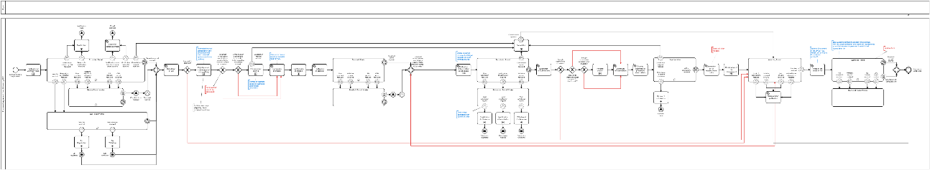

Figure 2 – BPMN for the general process of a FA[3]

## OCDS design

The diagram below shows the general data-set of a FA, which is a quite comprehensive and complex structure of the related transactional data which involves more than 10 parallel data-streams in its lifecycle:

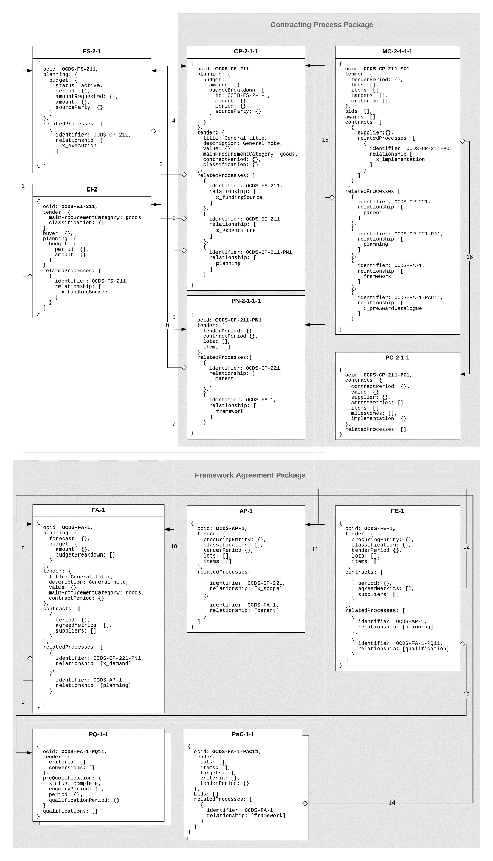

Figure 3 – OCDS design for a FA[4]

### Map of relations

|  |  |  |  |
| --- | --- | --- | --- |
| **№** | **Description** | **Code** | **Precondition** |
| 1 | FS as a funds related source to EI | x_fundingSource | Funds associated by a CA with a specific need |
| 2 | EI as to related class of need to CP | x_expenditureItem | A procurement process is initiated by a CA based on a specific classified need |
| 3 | FS as allocated funds source to CP | x_fundingSource | Funds allocated by a CA to cover a future contract (or a part of it) |
| 4 | CP as a subsidized stream to FS | x_execution | Funds approved to cover a future contract (or a part of it) |
| 5 | PN as a planning phase to CP | planning | Procurement plan regarding a specific procurement process |
| 6 | CP as a parent to a PN | parent | Planning phase is started for this procurement process |
| 7 | FA as a related framework to PN | framework | FA indicated by a CA for further aggregation |
| 8 | PN as a demand requested to be included to FA | x_demand | Planned demand is requested by a CA to be included into the scope of a FA managed by a CPB |
| 9 | AP as a planning phase to FA | planning | Aggregated demand for a specific FA |
| 10 | FA as a parent to a AP | parent | Aggregated planning is started for this FA |
| 11 | PN as an aggregated scope to AP | x_scope | A request for participation is approved by the CPB, and therefore the CA' demand is aggregated to the FA |
| 12 | AP as an indicative forecast to FE | planning | FA if initiated by the CPB based on an aggregated plan for this FA |
| 13 | PQ as a pre-qualification phase to FE | qualification | Pre-qualification phase is started for this FA |
| 14 | FA as a managing framework to PaC | framework | PCR is issued by the CPB and send to selected EOs |
| 15 | CP as a parent to MC | parent | FA execution is initiated under a specific procurement process aggregated by this FA |
| 16 | PC as implementation to MC | x_execution | Purchase contract is concluded under a FA with a specific procurement process |

Table 4 – Map of relations

### OCDS parallel records used to reflect OCDS design for FAs

##### EI

|  |  |  |
| --- | --- | --- |
| **Attribute** | **Description** | **Covered by** |
| Ocid | Global unique identifier for this EI | [OCDS 1.1](https://standard.open-contracting.org/latest/en/schema/identifiers/) |
| tender.mainProcurementCategory | Category of the subject of this EI | [OCDS 1.1](https://standard.open-contracting.org/latest/en/schema/codelists/" \l "procurement-category) |
| tender.classification | CPV classification of the subject of this EI | Not covered |
| Buyer | Organization in whose interests the need is declared | [OCDS 1.1.](https://standard.open-contracting.org/latest/en/schema/reference/" \l "release) |
| planning.budget.period | The aggregated period of availability of funding sources under this EI | [core_extension](https://github.com/open-contracting-extensions/ocds_budget_breakdown_extension/blob/master/release-schema.json) |
| planning.budget.amount | The absolute total value of all the funding sources under this EI | [core_extension](https://github.com/open-contracting-extensions/ocds_budget_breakdown_extension/blob/master/release-schema.json) |
| relatedProcesses | The link to the funding sources allocated for this EI | [OCDS 1.1](https://standard.open-contracting.org/latest/en/schema/reference/?highlight=relatedProcess" \l "relatedprocess) |

Table 5 – Attributes of EI

##### FS

|  |  |  |
| --- | --- | --- |
| **Attribute** | **Description** | **Covered by** |
| Ocid | Global unique identifier for this FS | [OCDS 1.1](https://standard.open-contracting.org/latest/en/schema/identifiers/) |
| planning.budget.period | The period of availability of this FS | [core_extension](https://github.com/open-contracting-extensions/ocds_budget_breakdown_extension/blob/master/release-schema.json) |
| planning.budget.amount | The absolute value of this FS | [core_extension](https://github.com/open-contracting-extensions/ocds_budget_breakdown_extension/blob/master/release-schema.json) |
| planning.budget.amountRequested | Future steps of representing the workflow of budget approvals | [Issue #616](https://github.com/open-contracting/standard/issues/616) |
| planning.budget.status | Future steps of representing the workflow of budget approvals | [Issue #616](https://github.com/open-contracting/standard/issues/616) |
| planning.budget.sourceParty | The organization related to this FS | [core_extension](https://github.com/open-contracting-extensions/ocds_budget_breakdown_extension/blob/master/release-schema.json) |
| relatedProcesses | The link to an EI this FS is related to | [OCDS 1.1](https://standard.open-contracting.org/latest/en/schema/reference/?highlight=relatedProcess#relatedprocess) |

Table 6 – Attributes of FS

##### CP

|  |  |  |
| --- | --- | --- |
| **Attribute** | **Description** | **Covered by** |
| ocid | Global unique identifier for this procurement process | [OCDS 1.1](https://standard.open-contracting.org/latest/en/schema/identifiers/) |
| planning.budget.amount | The overall value of the funds allocated for this procurement process | [core_extension](https://github.com/open-contracting-extensions/ocds_budget_breakdown_extension/blob/master/release-schema.json) |
| planning.budget.budgetBreakdown | Detailed budget breakdown under this procurement process, covering multiple budget funding and multiple periods | [core_extension](https://github.com/open-contracting-extensions/ocds_budget_breakdown_extension/blob/master/release-schema.json) |
| tender.title | An overall title for this procurement process | [OCDS 1.1.](https://standard.open-contracting.org/latest/en/schema/reference/" \l "release) |
| tender.description | An overall description for this procurement process | [OCDS 1.1.](https://standard.open-contracting.org/latest/en/schema/reference/" \l "release) |
| tender.value | The total upper estimated value of the procurement process | [OCDS 1.1.](https://standard.open-contracting.org/latest/en/schema/reference/" \l "release) |
| tender.mainProcurementCategory | Category of the subject of this procurement process | [OCDS 1.1](https://standard.open-contracting.org/latest/en/schema/codelists/" \l "procurement-category) |
| tender.classification | CPV classification of the subject of this procurement process | Not covered |
| buyer | Organization in whose interests the need is declared | [OCDS 1.1.](https://standard.open-contracting.org/latest/en/schema/reference/#release) |
| tender.contractPeriod | The period over which the contract is estimated or required to be active | [OCDS 1.1](https://standard.open-contracting.org/latest/en/schema/reference/" \l "tender) |
| relatedProcesses | Parallel processes related to a current one | [OCDS 1.1](https://standard.open-contracting.org/latest/en/schema/reference/" \l "tender) |
| *.relationship: x_fundingSource | Link to related FS(s) | [OCDS 1.1](https://standard.open-contracting.org/latest/en/schema/reference/?highlight=relatedProcess" \l "relatedprocess) |
|  |  |  |
| *.relationship: x_expenditure | Link to related EI(s) | [OCDS 1.1](https://standard.open-contracting.org/latest/en/schema/reference/?highlight=relatedProcess" \l "relatedprocess) |
| *.relationship: planning | Link to related PN | [OCDS 1.1](https://standard.open-contracting.org/latest/en/schema/reference/?highlight=relatedProcess#relatedprocess) |
| *.relationship: x_framework | Link to related FA (when subject is included in a FA) | [OCDS 1.1](https://standard.open-contracting.org/latest/en/schema/reference/?highlight=relatedProcess" \l "relatedprocess) |

Table 7 – Attributes of CP

##### PN

|  |  |  |
| --- | --- | --- |
| **Attribute** | **Description** | **Covered by** |
| Ocid | Global unique identifier for the PN under this procurement process | [OCDS 1.1](https://standard.open-contracting.org/latest/en/schema/reference/" \l "release) |
| tender.tenderPeriod | Indicative date (month or quarter) of call for proposals under this procurement process | [OCDS 1.1](https://standard.open-contracting.org/latest/en/schema/reference/" \l "tender) |
| tender.contractPeriod | Expected contract period for a contract concluded under this procurement process | [OCDS 1.1](https://standard.open-contracting.org/latest/en/schema/reference/" \l "tender) |
| tender.lots | Provisional division into lots | [core_extension](https://github.com/open-contracting-extensions/ocds_lots_extension) |
| tender.items | Provisional nomenclature of a subject of procurement | [OCDS 1.1](https://standard.open-contracting.org/latest/en/schema/reference/#tender) |
| relatedProcesses | Link to the parent procurement process | [OCDS 1.1](https://standard.open-contracting.org/latest/en/schema/reference/?highlight=relatedProcess" \l "relatedprocess) |

Table 8 – Attributes of PN

##### MC

|  |  |  |
| --- | --- | --- |
| **Attribute** | **Description** | **Covered by** |
| Ocid | Global unique identifier for the MC under this procurement process | [OCDS 1.1](https://standard.open-contracting.org/latest/en/schema/reference/#release) |
| tender.tenderPeriod | Period for submitting a bids in this MC | [OCDS 1.1](https://standard.open-contracting.org/latest/en/schema/reference/#tender) |
| tender.lots | Lots of this MC | [core_extension](https://github.com/open-contracting-extensions/ocds_lots_extension) |
| tender.items | Nomenclature of this MC | [OCDS 1.1](https://standard.open-contracting.org/latest/en/schema/reference/" \l "tender) |
| tender.criteria | Any evaluation criteria applied for this MC | [core_extension](https://github.com/open-contracting-extensions/ocds_requirements_extension) |
| tender.targets | Any indicative metrics criteria applied for this MC | [core_extension](https://github.com/open-contracting-extensions/ocds_metrics_extension) |
| Bids | List of tenders collected under this MC | [core_extension](https://github.com/open-contracting-extensions/ocds_bid_extension) |
| Awards | Award-decision taken under this MC | [OCDS 1.1](https://standard.open-contracting.org/latest/en/schema/reference/#tender) |
| contracts[*].supplier | List of suppliers awarded under this MC | [OCDS 1.1](https://standard.open-contracting.org/latest/en/schema/reference/#tender) |
| contract[*].AwardID | Reference on award for purchase contract concluded under this MC | [OCDS 1.1](https://standard.open-contracting.org/latest/en/schema/reference/#tender) |
| relatedProcesses | Parallel processes related to a current one | [OCDS 1.1](https://standard.open-contracting.org/latest/en/schema/reference/?highlight=relatedProcess" \l "relatedprocess) |
| *.relationship: parent | Link to a procurement process | [OCDS 1.1](https://standard.open-contracting.org/latest/en/schema/reference/?highlight=relatedProcess#relatedprocess) |
| *.relationship: planning | Link to PN | [OCDS 1.1](https://standard.open-contracting.org/latest/en/schema/reference/?highlight=relatedProcess" \l "relatedprocess) |
| *.relationship: framework | Link to FA | [OCDS 1.1](https://standard.open-contracting.org/latest/en/schema/reference/?highlight=relatedProcess#relatedprocess) |
| *.relationship: x_preAwardCatalogue | Link to PCR | [OCDS 1.1](https://standard.open-contracting.org/latest/en/schema/reference/?highlight=relatedProcess#relatedprocess) |

Table 9 – Attributes of MC

##### PC

|  |  |  |
| --- | --- | --- |
| **Attribute** | **Description** | **Covered by** |
| Ocid | Global unique identifier for the PC under this procurement process | [OCDS 1.1](https://standard.open-contracting.org/latest/en/schema/reference/" \l "release) |
| contracts[*].contractPeriod | A period for this PC | [OCDS.1.1](https://standard.open-contracting.org/latest/en/schema/reference/" \l "contract) |
| contracts[*].supplier | The EO winner of this PC | [OCDS.1.1](https://standard.open-contracting.org/latest/en/schema/reference/#contract) |
| contracts[*].value | The value of this PC | [OCDS.1.1](https://standard.open-contracting.org/latest/en/schema/reference/" \l "contract) |
| contracts[*].agreedMetrics | The metrics agreed under this PC | [core_extension](https://github.com/open-contracting-extensions/ocds_metrics_extension) |
| contracts[*].items | A scope of performance under this PC | [OCDS.1.1](https://standard.open-contracting.org/latest/en/schema/reference/" \l "contract) |
| contracts[*].milestones | The milestones of this PC | [OCDS.1.1](https://standard.open-contracting.org/latest/en/schema/reference/" \l "contract) |
| contracts[*].implementation | An implementation record under this PC | [OCDS.1.1](https://standard.open-contracting.org/latest/en/schema/reference/#contract) |

Table 10 – Attributes of EI

##### FA

|  |  |  |
| --- | --- | --- |
| **Attribute** | **Description** | **Covered by** |
| Ocid | Global unique identifier for this FA | [OCDS 1.1](https://standard.open-contracting.org/latest/en/schema/reference/?highlight=relatedProcess" \l "relatedprocess) |
| planning.forecast | The indicative scope of this FA | [core_extension](https://github.com/open-contracting-extensions/ocds_metrics_extension) |
| tender.title | Title for the FA | [OCDS 1.1](https://standard.open-contracting.org/latest/en/schema/reference/?highlight=relatedProcess" \l "relatedprocess) |
| tender.description | Description for the FA | [OCDS 1.1](https://standard.open-contracting.org/latest/en/schema/reference/?highlight=relatedProcess" \l "relatedprocess) |
| tender.value | Indicative value of this FA | [OCDS 1.1](https://standard.open-contracting.org/latest/en/schema/reference/?highlight=relatedProcess" \l "relatedprocess) |
| tender.mainProcurementCategory | Main procurement category of this FA | [OCDS 1.1](https://standard.open-contracting.org/latest/en/schema/reference/?highlight=relatedProcess" \l "relatedprocess) |
| tender.contractPeriod | Indicative duration of this FA | [OCDS 1.1](https://standard.open-contracting.org/latest/en/schema/reference/?highlight=relatedProcess" \l "relatedprocess) |
| Contracts | List of PCs concluded under this FA | [OCDS 1.1](https://standard.open-contracting.org/latest/en/schema/reference/?highlight=relatedProcess" \l "relatedprocess) |
| relatedProcesses | List of parallel processes related to this FA | [OCDS 1.1](https://standard.open-contracting.org/latest/en/schema/reference/?highlight=relatedProcess" \l "relatedprocess) |
| *.relationship: x_demand | Link to PNs | [OCDS 1.1](https://standard.open-contracting.org/latest/en/schema/reference/?highlight=relatedProcess" \l "relatedprocess) |
| *.relationship: planning | Link to AP | [OCDS 1.1](https://standard.open-contracting.org/latest/en/schema/reference/?highlight=relatedProcess" \l "relatedprocess) |

Table 11 – Attributes of FA

##### AP

|  |  |  |
| --- | --- | --- |
| **Attribute** | **Description** | **Covered by** |
| ocid | Global unique identifier for the AP under this FA | [OCDS 1.1](https://standard.open-contracting.org/latest/en/schema/reference/?highlight=relatedProcess#relatedprocess) |
| tender.classification | Classification of this AP according to CPV | [OCDS 1.1](https://standard.open-contracting.org/latest/en/schema/reference/?highlight=relatedProcess#relatedprocess) |
| tender.tenderPeriod | Indicative start date for the conclusion of the FA | [OCDS 1.1](https://standard.open-contracting.org/latest/en/schema/reference/?highlight=relatedProcess#relatedprocess) |
| tender.items | Nomenclature of this AP | [OCDS 1.1](https://standard.open-contracting.org/latest/en/schema/reference/?highlight=relatedProcess#relatedprocess) |
| tender.lots | Lots this AP is divided into | [core_extension](https://github.com/open-contracting-extensions/ocds_lots_extension) |
| relatedProcesses | Parallel processes related to this AP | [OCDS 1.1](https://standard.open-contracting.org/latest/en/schema/reference/?highlight=relatedProcess#relatedprocess) |
| *.relationship: x_scope | Link to PNs | [OCDS 1.1](https://standard.open-contracting.org/latest/en/schema/reference/?highlight=relatedProcess#relatedprocess) |
| *.relationship: parent | Link to FA | [OCDS 1.1](https://standard.open-contracting.org/latest/en/schema/reference/?highlight=relatedProcess#relatedprocess) |

Table 12 – Attributes of AP

##### FE

|  |  |  |
| --- | --- | --- |
| **Attribute** | **Description** | **Covered by** |
| ocid | Global unique identifier for the FE under this FA | [OCDS 1.1](https://standard.open-contracting.org/latest/en/schema/reference/?highlight=relatedProcess#relatedprocess) |
| tender.procuringEntity | CA in this FA | [OCDS 1.1](https://standard.open-contracting.org/latest/en/schema/reference/?highlight=relatedProcess#relatedprocess) |
| tender.classification | Classification of this FA according to CPV | [OCDS 1.1](https://standard.open-contracting.org/latest/en/schema/reference/?highlight=relatedProcess#relatedprocess) |
| relatedProcesses | Parallel processes related to this FE | [OCDS 1.1](https://standard.open-contracting.org/latest/en/schema/reference/?highlight=relatedProcess#relatedprocess) |
| *.relationship: planning | Link to AP | [OCDS 1.1](https://standard.open-contracting.org/latest/en/schema/reference/?highlight=relatedProcess#relatedprocess) |
| *.relationship: qualification | Link to PQ | [OCDS 1.1](https://standard.open-contracting.org/latest/en/schema/reference/?highlight=relatedProcess#relatedprocess) |

Table 13 – Attributes of FE

##### PQ

|  |  |  |
| --- | --- | --- |
| **Attribute** | **Description** | **Covered by** |
| ocid | Global unique identifier for the PQ under this FA | [OCDS 1.1](https://standard.open-contracting.org/latest/en/schema/reference/?highlight=relatedProcess#relatedprocess) |
| preQualification.enquiryPeriod | Enquiry period allocated under this PQ | [core_extension](https://github.com/open-contracting-extensions/ocds_qualification_extension) |
| preQualification.period | Period for submission of EoIs | [core_extension](https://github.com/open-contracting-extensions/ocds_qualification_extension) |
| preQualification.qualificationPeriod | Period for consideration of EoIs collected by the CA | [core_extension](https://github.com/open-contracting-extensions/ocds_qualification_extension) |
| submissions | EoIs by interested EOs | Not covered |
| qualifications | Qualification decisions by the CA against received EoI | Not covered |

Table 14 – Attributes of PQ

##### PQC

|  |  |  |
| --- | --- | --- |
| **Attribute** | **Description** | **Covered by** |
| tender.criteria | Any qualification and/or evaluation criteria applied by the CA | [core_extension](https://github.com/open-contracting-extensions/ocds_requirements_extension) |
| tender.conversions | Any weighting related to applied criteria | Not covered |
| tender.otherCriteria | Detailed information about any other requirements or techniques used by the CA | [core_extension](https://github.com/open-contracting-extensions/ocds_otherRequirements_extension) |

Table 15 – Attributes of PQC

##### PAC

|  |  |  |
| --- | --- | --- |
| **Attribute** | **Description** | **Covered by** |
| ocid | Global unique identifier for the PAC under this FA | [OCDS 1.1](https://standard.open-contracting.org/latest/en/schema/reference/?highlight=relatedProcess#relatedprocess) |
| tender.items | Nomenclature requested by the CA within PCR | [OCDS 1.1](https://standard.open-contracting.org/latest/en/schema/reference/?highlight=relatedProcess#relatedprocess) |
| tender.targets | Any targets indicated by the CA within PCR | [core_extension](https://github.com/open-contracting-extensions/ocds_metrics_extension) |
| tender.criteria | Evaluation criteria related to a nomenclature requested by this PCR | [core_extension](https://github.com/open-contracting-extensions/ocds_requirements_extension) |
| tender.tenderPeriod | Period for submission of PACs by invited EOs | [OCDS 1.1](https://standard.open-contracting.org/latest/en/schema/reference/?highlight=relatedProcess#relatedprocess) |
| bids | PACs submitted by invited EOs | [core_extension](https://github.com/open-contracting-extensions/ocds_bid_extension) |
| relatedProcesses | Parallel processes related to this PAC | [OCDS 1.1](https://standard.open-contracting.org/latest/en/schema/reference/?highlight=relatedProcess#relatedprocess) |
| *.relationship: framework | Link to FA | [OCDS 1.1](https://standard.open-contracting.org/latest/en/schema/reference/?highlight=relatedProcess#relatedprocess) |

Table 16 – Attributes of PaC

## OCDS blocks involved in the conclusion of a FA

All the aforementioned blocks are involved in the entire FA lifecycle. However, regarding the conclusion of a FA, only several are involved:

|  |  |
| --- | --- |
| **Block** | **Description** |
| FA | Describes a specific instance of a FA initiated by a CPB. |
| AP | Describes aggregate demand as per CPB analysis. |
| FE | Describes the conclusion of the FA. |
| PAC | Describes a structured electronic catalogue with specific categories of goods or services for a FA, as well as the relevant indicative prices received from selected EOs (in the case of request of electronic catalogues to the selected EOs) |

Table 17 - OCDS blocks involved in the conclusion of a FA

## Building components

The following building components are relevant for the conclusion of a FA:

* Initiation of a FA: Offline process conducted by the CPB. It is based on the analysis of CAs’ demands described through the lists of EIs as a part of their budgeting process. Having all the needs described by the CAs that want to be party of the FA, the CPB can determine the global needs and specificities of the FA (overall value, geographical distribution, timings, etc.). The main goal of this stage is to decide on the procurement strategy for the conclusion of the FA and inform the CAs;
* Aggregated planning: It contains information about multiple individual procurement plans. Through the aggregation of demand, CPBs are able to significantly diminish costs and get better value for money through economies of scale, although procurement techniques that involve aggregation, such as FA, usually take longer to award than non-aggregated procurement processes;
* Design of a FA: Based on the procurement strategy adopted by the CPB, the relevant aspects regarding the conclusion and execution of the FA are defined in order to initiate the FA process;
* Conclusion of a FA: FAs are frequently set by CPBs, which can either act on their own behalf or on behalf of a number of CAs. The successful tenderers are usually selected using open or restricted procedures (although negotiated procedures can also be used when the appropriate conditions are met). The FA determines the method in which specific contracts based on the FA will be awarded to selected EOs, as well as the terms applying to that awards for a certain period of time;
* Pre-award catalogue request: The PAC provides a list and high-level information and requirements on the goods or services included within the FA, in order for the EOs to be able to decide whether they have the capacity and are interested or not in being party of the FA. A PAC request does not contain any vendor-specific data.

### Initiation of a FA

The diagram below shows the processes for the initiation of a FA:

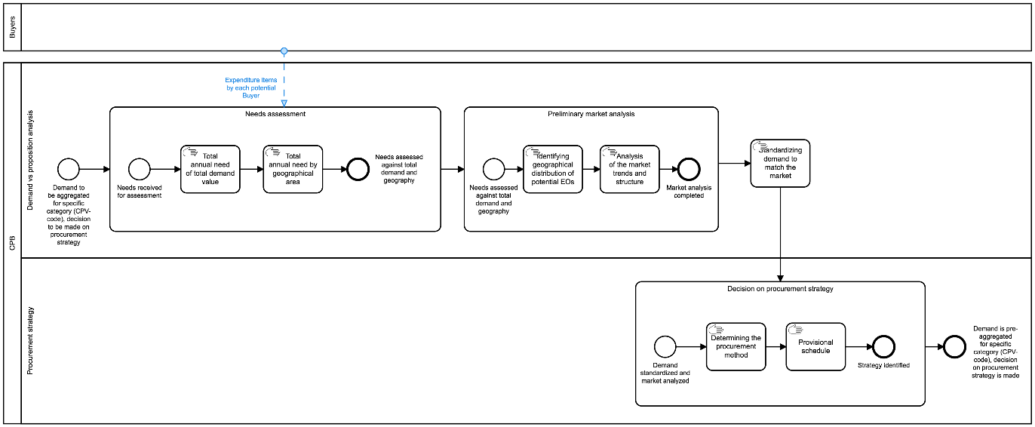

Figure 4 - BPMN for initiation of a FA[5]

All actions regarding aggregation of demand and budget are described in the following section.

### Aggregated planning

##### BPMN

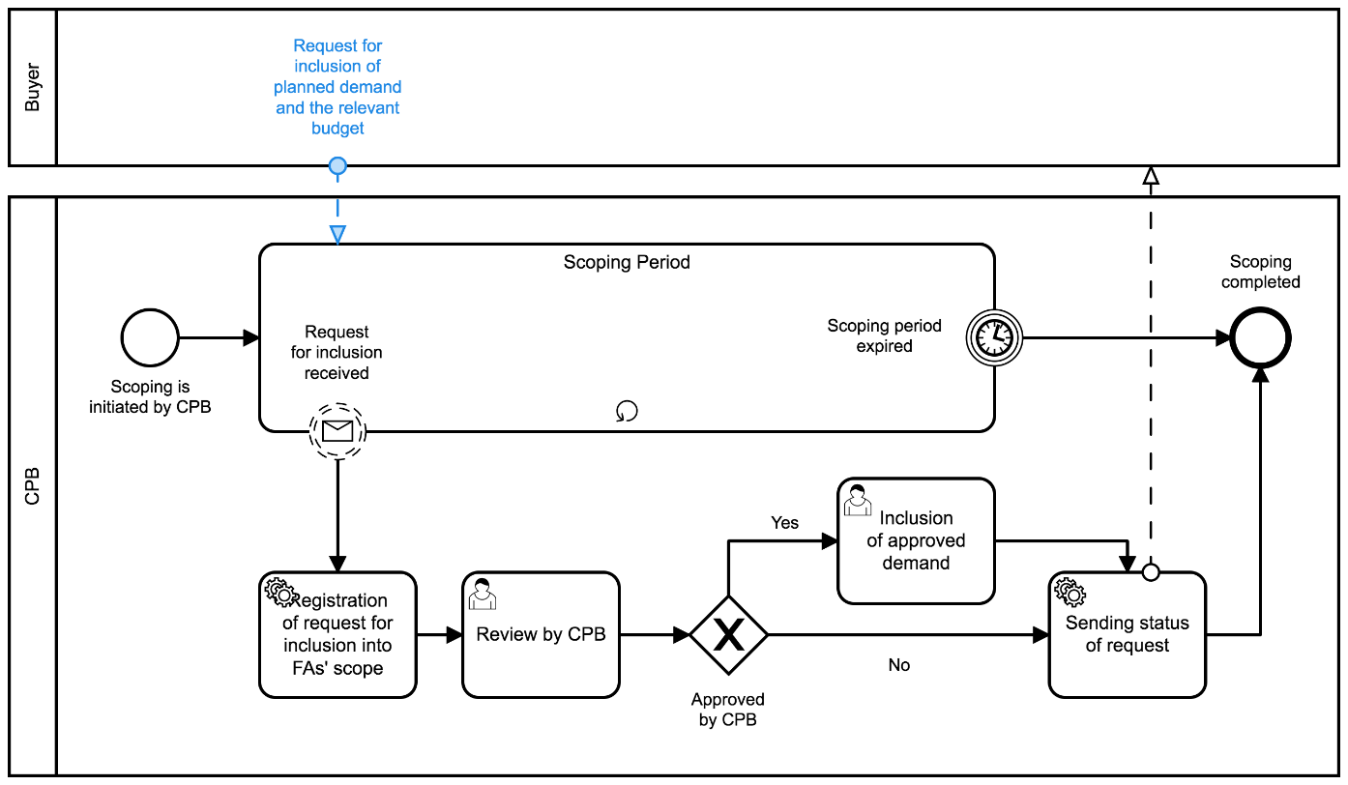

Figure 5 - BPMN for aggregated planning[6]

##### Component diagram

On a data level, aggregation means setting up a relationship between different data-sets and inheritance of specific data in order to reflect aggregation and its scope. The logic illustrated in the following component diagram consists of a sequence of relations of sets based on the business process performed:

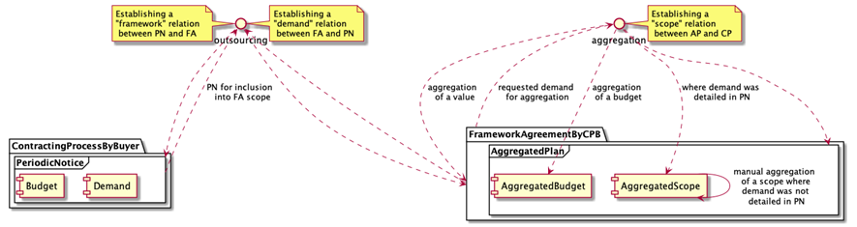

Figure 5 – Component diagram for aggregated planning

According to the business process above, once a CA becomes aware of the intention of a CPB to conduct a FA for a specific category of goods or services, the CA can request the CPB the inclusion of the CA’s demand and related budget into the scope of the FA. In order to do so, the CA needs to describe the demand first by initiating a procurement process (although not a procurement procedure, which will be initiated later on once the FA is concluded and the CA wants to conduct a purchase under this FA) against previously declared annual needs (EI classified with a certain CPV code) and publication of a relevant PN (the aggregation demand notice) describing the provisional schedule, budget allocated, etc. Once these data is provided by the CA, a relation between the PN and the FA can be established. Such a relation serves as a data-hook of inclusion requests recorded.

On the CPB side, each request for inclusion from a CA has to be reviewed by the CPB, who will decide on whether this request is a subject of this FA from classification, geography, volume, etc. perspectives. If it is compliant and the CPB decides to include this demand into the scope of the future FA, such demand is aggregated through establishing a relation between the PN and the aggregated plan.

The CPB proceeds in the same way with all the requests collected during a certain period of time and, having the final aggregated scope, the CPB can complete the scoping period and start designing the FA and preparing the pre-qualification phase.

|  |
| --- |
| Since aggregation of a subject of procurement from multiple sources (PNs by CAs) into a single common scope (AP) doesn't seem a linear process and often requires human-analysis, at this stage subject aggregation, together with “lots” strategy, is conducted by the CPB as a manual process. |

### Design of a FA

##### Determining categories and products

FAs are usually used for repeating needs and enable CAs to manage procurement when they cannot objectively foresee the exact type and/or amount of supplies, services and works for the duration of a given period.

During the design of the FA, the categories and products that will be purchased under this FA must be defined, as well as the possibility of substitution and to what extent. However, when certain terms and conditions of the procurement cannot be established with sufficient precision in the conclusion of the FA, the CA will be able to establish or refine them through MC processes under the FA.

Technically, determining product categories is the determination of a relevant list of items with aggregated classification according to CPV and decomposed place of performance (delivery).

Find below the simplest case, when the only category of goods scoped for relatively same (or even same) geography:

|  |
| --- |
| {  "tender": {  "items": [  {  "id": "001",  "description": "Notebooks",  "quantity": 200,  "classification": {  "schema": "CPV",  "id": "30213100-6",  "description": "Portable computers"  }  },  "deliveryAddress": {  "region": "Florida"  }  ]  }  } |

Figure 7 – Simplest case

Find below a more complex case when a common volume in a category of goods is divided through geography:

|  |
| --- |
| {  "tender": {  "items": [  {  "id": "001",  "description": "Notebooks",  "quantity": 150,  "classification": {  "schema": "CPV",  "id": "30213100-6",  "description": "Portable computers"  }  },  "deliveryAddress": {  "region": "Florida"  },  {  "id": "002",  "description": "Notebooks",  "quantity": 50,  "classification": {  "schema": "CPV",  "id": "30213100-6",  "description": "Portable computers"  }  },  "deliveryAddress": {  "region": "California"  }  ]  } |

Figure 8 – Complex case

##### Decision on minimum technical specifications

FAs are not a specific procurement procedure or a type of procurement, but a technique for aggregated procurement used for established and repetitive needs when the CA does not know in advance either the exact contract amount and/or exactly when the need will occur. Therefore, FAs allow CAs to set the parameters for purchases without having to define the precise amounts or the full specifications, providing streamlined processes for standardized purchases. Subsequently, contracts based on a FA will be conducted only with the EOs that are party to this FA.

Therefore, two different stages must be considered regarding FAs:

1. Conclusion on the FA: In order to conclude a FA, CAs can use any of the usual procedures, and open and restricted procedures are usually applied. Consequently, the normal processes and normal rules apply, in particular those concerning publicity, time limits, criteria for exclusion, selection and award. The conclusion of the FA ends with the selection of the EOs that will be party of the FA.
2. Contracts under the FA: Different processes can be conducted for contracts based on FAs, such as direct purchase, request for quotation and second stage competition. Only those EOs party of the FA, that is, that were selected during the conclusion of the FA, can be awarded contracts under this FA.

When a CA deals with a large portfolio of products (for example 10,000 types of office supplies) the question arises, whether all these products must be identified and considered at the award stage in the FA, and to what extent they need to be described. It seems to be reasonable to describe the subject matter in a broad manner since such an approach gives the flexibility needed both when concluding a framework agreement and when using it.

On the other hand, a sort of balance in clarity for both CA and EOs can be achieved by including a clear, precise and unequivocal review clause in the framework agreement, in which it is predicted that a substitution of products is allowed. Such review clauses shall state the scope and nature of possible modifications or options, as well as the conditions under which they may be used. They shall not provide for modifications or options that would alter the overall nature of the framework agreement. What needs to be considered in drafting the review clauses is, whether the allowed substitution regards a change of a product for a new one, but with the terms of keeping the agreed price, or whether the substitution will allow an upgrade of a product connected with a price increase.

Technically, decisions on minimum technical specification and introduction of relevant review clauses are the determination of a list of targets and criteria for each bunch of such technical specifications expressed with a review clause. targets describe a list of minimum, maximum and expected allowed values or its ranges for the certain attributes of a particular category (item), and criteria is a way on how to requisite EOs’ offers against prescribed targets:

|  |
| --- |
| {  "tender": {  "items": [  {  "id": "001",  "description": "Simple notebooks",  "quantity": 100,  "classification": {  "schema": "CPV",  "id": "30213100-6",  "description": "Portable computers"  },  "deliveryAddress": {  "region": "Florida"  }  }  ],  "targets": [  {  "id": "001",  "title": "Product metrics",  "description": "Minimum technical requirements",  "relatesTo": "item",  "relatedItem": "001",  "observations": [  {  "id": "001-1",  "note": "Diagonal",  "measure": 15,  "unit": {  "id": "",  "name": "inches"  },  "relatedRequirementID": "001-1-2"  },  {  "id": "001-2",  "note": "HDD Volume",  "measure": 102400,  "unit": {  "id": "",  "name": "Mbyte"  },  "relatedRequirementID": "001-1-4"  }  ]  },  {  "id": "002",  "title": "Estimated maximum budget",  "description": "Exepected maximum unit price",  "relatesTo": "item",  "relatedItem": "001",  "observations": [  {  "id": "002-1",  "note": "Unit price in UAH",  "value": {  "amount": 25000,  "currency": "UAH",  "valueAddedTaxIncluded": true  }  }  ]  }  ],  "criteria": [  {  "id": "007",  "title": "Characteristics",  "relatesTo": "item",  "relatedItem": "001",  "requirementGroups": [  {  "id": "001-1",  "requirements": [  {  "id": "001-1-1",  "title": "Processor family",  "dataType": "string"  },  {  "id": "001-1-2",  "title": "Diagonal",  "dataType": "number",  "minValue": 15  },  {  "id": "001-1-3",  "title": "RAM Volume",  "dataType": "integer"  },  {  "id": "001-1-4",  "title": "HDD Volume",  "dataType": "integer",  "minValue": 102400  }  ]  }  ]  }  ]  }  } |

Figure 9 – Simplest case

As shown in the example above, criteria in this context can be used not only against metrics prescribed but also in order to describe any other information not covered by any observation, but needed from a requisition perspective.

##### Decision on lots

FAs can be divided into lots. Technically, the decision on lots is a determination of a relevant list of lots with aggregated classification according to CPV.

|  |
| --- |
| {  "tender": {  "lots": [  {  "id": "001",  "status": "active",  "title": "Simple notebooks",  "classification": {  "scheme": "CPV",  "id": "30213100-6",  "description": "Portable computers"  }  },  {  "id": "002",  "status": "active",  "title": "Advanced notebooks",  "classification": {  "scheme": "CPV",  "id": "30213100-6",  "description": "Portable computers"  }  }  ]  }  } |

Figure 9 – Division into lots

##### Determining the characteristics of the FA

##### Fixed and non-fixed terms

When it comes to FAs that do not include all terms and conditions, it will be necessary to establish or refine all non-fixed terms through MC under this FA.

* Information about options regarding additional purchases: A CA may have a right (but not the obligation) to additional purchases from an EO while the contract is valid. For example, a contract may concern a thousand uniforms, and the CA may have the option to request an additional hundred uniforms. This may be useful when, with the conclusion of the FA, the CA doesn't yet know whether a planned increase in staff will take place.

The options.hasOptions field can be set to true, and the options.description field can describe the options for additional purchases. hasOptions and options.description can also be set on Lot objects in the tender.lots array:

|  |
| --- |
| {  "tender": {  "lots": [  {  "id": "001",  "options": {  "hasOptions": true,  "description": "The buyer has the option to buy an additional hundred uniforms."  }  }  ]  }  } |

Figure 11 – Options for additional purchases

* Information on the recurrence of the procurement process. It indicates that the contract is likely to be re-launched, or re-established, in the foreseeable future. Note that this does not mean awarding multiple contracts within a single FA; in these cases, these fields should not be used. This information can be useful, for example, to EOs deciding whether to invest or not into machinery necessary for a particular contract since, with this information, they know that there will likely be an opportunity to win similar contracts in future years, which may make the investment more worthwhile.

|  |
| --- |
| {  "tender": {  "lots": [  {  "id": "001",  "options": {  "hasOptions": true,  "description": "The buyer has the option to buy an additional hundred uniforms."  }  }  ]  }  } |

Figure 12 – Recurrence

* Description of the options for the renewal of contracts

|  |
| --- |
| {  "tender": {  "lots": [  {  "id": "001",  "renewals": {  "hasRenewals": true,  "variantsDetails": "Contracts are due to be renewed one time at the end of the initial term"  }  }  ]  }  } |

Figure 13 – Renewals

* Information about variants

|  |
| --- |
| {  "tender": {  "lots": [  {  "id": "001",  "variants": {  "hasVariants": true,  "variantsDetails": "Any relevant items are permitted"  }  }  ]  }  } |

Figure 14 – Variants

##### Duration

The duration of a FA shall not exceed four years, save in exceptional cases duly justified, in particular by the subject of the FA.

|  |
| --- |
| {  "tender": {  "lots": [  {  "id": "001",  "contractPeriod": {  "durationInMonth": 36,  "startDate": "",  "endDate": ""  }  }  ]  }  } |

Figure 15 – Duration of the FA

##### Limitations on the number of selected EOs

When the CA intends to select more than one EO to be party of a FA (multi-supplier FA), the minimum number of EOs is three (provided that there are three suitably qualified EOs). There is no limitation on the maximum number of EOs that can be party of a multi-supplier FA, but if the CA wants to establish a maximum, it must be indicated in the Contract Notice. When this is a case, pre-selection instead of pre-qualification will be conducted in order to score all the candidates.

To limit the number of selected EOs, secondStage building block shall be within inside the tender (or even for a given specific lot)as shown below:

* For tender:

|  |
| --- |
| {  "tender": {  "secondStage": {  "minimumCandidates": 2,  "maximumCandidates": 5  }  }  } |

Figure 16 – Limitation on the number of candidates at tender level

* For a specific lot:

|  |
| --- |
| {  "tender": {  "lots": [  {  "secondStage": {  "minimumCandidates": 2,  "maximumCandidates": 5  }  }  ]  }  } |

Figure 17 – Limitation on the number of candidates at lot level

##### Other criteria

Other requirements for participation and terms governing the limitation of the number of candidates to be invited to submit a bid, can be defined using secondStage.

Technically, the definition of other requirements is an indication of a code of a core criterion to be applied for a future limitation of the number of candidates to be invited to submit a bid, as reductionCriteria and the specification of a way of how this criterion to be applied with qualificationSystemMethods:

* reductionCriteria
  + When reductionCriteria: scoring, there is a limitation of a number of candidates to be invited. The values for further qualification for reduction will be scored either automatically or manually (depending on the qualificationSystemMethods), based on the set of relevant requirementResponses received from EOs in response to the requirements indicated by the CA;
  + when reductionCriteria: none, there is no limit for the number of candidates to be invited to submit a bid.
* qualificationSystemMethods
  + When qualificationSystemMethods: automated, the selection of EOs will be approached automatically.
  + where qualificationSystemMethods: manual - the selection of EOs will be approached manually by the CA;

The otherCriteria block is expressed as a separate building block in accordance with: <https://github.com/open-contracting-extensions/ocds_otherRequirements_extension>

|  |
| --- |
| {  "tender": {  "otherCriteria": {  "qualificationSystemMethods": [  "automated"  ],  "reductionCriteria": "scoring"  }  }  } |

Figure 18 – Other criteria

##### Award criteria for each category of products

Award criteria are the criteria that constitute the basis on which the CA selects the best tender and awards a contract. These criteria must be established in advance by the CA and must guarantee fair competition. Contracts can be awarded based on:

* Lowest-price: the contract is awarded to the EO who offers the lowest price for a compliant tender. The price is the only factor that is taken into consideration when selecting the best compliant tender. Tenders are evaluated using a pass or fail system, and no cost analysis or quality considerations are taken into account;
* Most Economically Advantageous Tender (MEAT): criteria other than price are considered when evaluating tenders, such as quality, delivery time, after-sales services, etc. Each criterion is given a relative weighting by the CA which reflects its relative importance. The selection of the MEAT is aimed at identifying the tender that offers best value-for-money.

Technically, the definition of award criteria is an indication of a code of criteria to be applied using awardCriteria and the specification of how this criterion must be applied with awardCriteriaDetails:

##### Award criteria

Awarding criterion is a general indicator on which the award decision will be based:

* Where awardCriteria: priceOnly, only bid.value is to be compared in order to identify the most suitable tender;
* where awardCriteria: costOnly, assumption is that all the tenderers have a same value of an offer. This means that the normalised price needs to be calculated for each tender received, based on an estimated value;
* where awardCriteria: qualityOnly, assumption is that the price doesn't matter and the only valuable part of the tender is the quality, meaning the set of values of criteria, selected by the EO while submitting a tender. This means that the normalised price needs to be calculated for each tender received, based on '1';
* where awardCriteria: ratedCriteria, assumption is that both price and quality matter. This means that the normalised price needs to be calculated for each tender received based on its value.

##### Award criteria details

Regarding how awarding criteria is to be applied for initial scoring of the tenders received using separate tender.awardCriteriaDetails attribute, the CA prescribes how all the tenders received shall be scored (by the System) for further evaluation:

* Where awardCriteriaDetails: automated, the awarding will be approached automatically based on awardCriteria and a set of relevant requirementResponses received from the tenderers against the requirements applied by the CA;
* where awardCriteriaDetails: manual, the awarding will be approached manually by the CA.

|  |
| --- |
| {  "tender": {  "awardCriteria": "priceOnly",  "awardCriteriaDetails": "automated"  }  } |

Figure 19 – Award criteria

The CA must provide the following information in the CN or contract documents:

* Criteria used for the selection of the MEAT;
* relative weight of each criterion or descending order of importance of these criteria (when, in the opinion of the CA, weighting is not possible).

##### Criteria and requirements

Award criteria must be:

* Linked to the subject-matter of the procurement procedure;
* aimed at identifying the MEAT and have no other purposes;
* objective and objectively quantifiable.

A separate criteria array can be added into the tender building block according to a criteria schema in order to describe:

* criteria[*].relatesTo: tenderer, qualification criteria and its minimum requirements;
* criteria[*].relatesTo: lot || item, specific requirements related to the subject-matter of the procurement procedure, its delivery/performance;
* criteria[*].relatesTo: procuringEntity, requirements related to the CA (e.g. obligation on declaration of non-conflict of interest) and criteria to be evaluated by a Committee.

|  |
| --- |
| {  "tender": {  "criteria": [  {}  ]  }  } |

##### Figure 20 – CriteriaWeitghting

The weighting system allows the CA to inform EOs about the relative importance of each criterion in order for EOs to better prepare their tenders. At the same time, through the weighting system, the CA minimises the possibilities for arbitrary decisions during the process of evaluation of tenders.

CAs may express the relative weighting of criteria using a range with an «appropriate» maximum spread. This spread must be appropriate in the sense that it cannot be so broad (for example between 10% and 90%) that it would result in a breach of the transparency principle and that it would not provide any valuable indication to potential tenderers of the actual relative importance that the CA assigns to each criterion used. Also, inappropriate weighting could cause problems when conducting the evaluation of tenders, and could mean that the tender offering the best value-for-money would not be selected.

A separate conversions array can be added into tender building block. Conversionsis a tool that allows describing used conversions and its applicable coefficients in order to:

* Describe used conversionsand its applicable coefficients, either as a list of precise values or as a mathematical formula for the calculation of the value of a particular coefficientin this particular case (depending on the value received within requirementResponse related to a specific requirement);
* relate each conversion used (together with coefficients) with used criteria or targets(where applicable);
* include applicable options to used criteria or observations for targets*.*

|  |
| --- |
| {  "tender": {  "conversions": [  {}  ]  }  } |

Figure 20 – Conversions

More information is available on [coefficients and conversions](https://ustudio.atlassian.net/wiki/spaces/VISION/pages/574357514/Coefficients+for+conversion).

### Conclusion of a FA

The conclusion of a FA is preceded by a needs assessment, a market analysis and an aggregate planning by the CPB, based on the individual needs declared by the CAs party to the FA.

Once these previous stages are fulfilled, it is possible to conduct the process of FA conclusion described in this section.

##### State-chart diagram

The sequence of a stages applicable for the conclusion of a FA is the following:

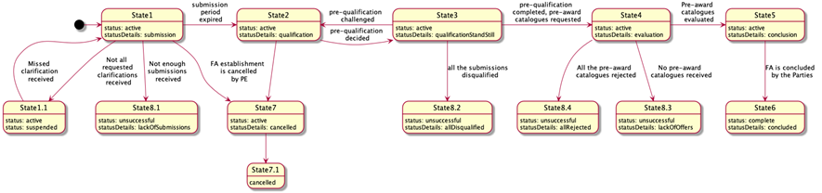

Figure 22 – State-chart diagram for the conclusion of a FA

##### OCDS dataset

##### Announcement of the initiation of the FA

The announcement of the initiation of a FA is made through the publication of a CN that provides:

* General procurement information;
* list of products and categories included in the FA;
* minimum technical specifications;
* lots, where applicable;
* fixed and non-fixed terms and conditions;
* duration of the FA;
* limitations on the number of suppliers, where applicable;
* qualification criteria and techniques.

##### Call for enquiries

In order to indicate the start date and end date of the explanatory phase of a procurement process established by the CA, a separate enquiryPeriod object must be added into the tender building block which will reflect the end date indicated by the CA, and its start date will reflect the moment of initiation of the explanatory phase in the system:

|  |
| --- |
| {  "tender": {  "enquiryPeriod": {  "startDate": "",  "endDate": ""  }  }  } |

Figure 23 – Enquiry period

##### Pre-qualification modality

The pre-qualification phase shall be launched in order to receive requests for participation from interested EOs. The following options must be taken into consideration:

* Pre-qualification establishment: A separate preQualification block shall be included into the Contract Notice where preliminary qualification or selection of the candidates to be invited to submit an offer is needed.

|  |
| --- |
| {  "preQualification": {  "id": "",  "status": "",  "procuringEntity":{}  }  } |

Figure 24 – PreQualification

* Call for EoI: Submission of EoIs is only available during a certain period determined in the stage of pre-qualification. In order to reflect such a period, a separate object period must be added into the preQualification block.

|  |
| --- |
| {  "preQualification": {  "period": {  "startDate": "",  "endDate": ""  }  }  } |

Figure 25 – Call for EoI

A PAC request can also be published in the situations described in section 2.5.5 of this document.

##### State1 - Submission phase (active.submission)

##### Enquiries - requests and clarifications

During the enquiry period (tender.enquiryPeriod), any interested EO is allowed to send enquiries, that is, requests for clarification. Such requests remain anonymous until tender.enquiryPeriod.endDate. After tender.enquiryPeriod.endDate, no more enquiries can be received.

* Enquiries: All the enquiries received within the tender.enquiryPeriod must be disclosed inmediately as an enquiries array item. Enquiries authors remain confidential until the start of the evaluation.

|  |
| --- |
| {  "tender": {  "enquiries": [  {  "id": "",  "title": "",  "description": "",  "relatedLot": ""  }  ]  }  } |

Figure 26 – Enquiries

* Answers: During enquiryPeriod, the CA is able to submit an answer to each question received.

|  |
| --- |
| {  "tender": {  "enquiries": [  {  "id": ""  "answer": "",  "dateAnswered": ""  }  ]  }  } |

Figure 27 – Answers to enquiries

##### Submission of EoI

The submission of EoIs is only allowed during a specific period of time, determined by a pre-qualification stage. In order to reflect this period, a separate period object can be added into the preQualification block, where the specific timeframe for EoIs is determined. Thus, within a given preQualification.period any interested EO is allowed to send a submissions, that is, a request for participation or EoI. Each request shall fulfil all the requirements set by the CA, providing an array of requirementResponses.

|  |
| --- |
| Having a set of requirements predefined by the CA and a number of values available for each requirement, EOs shall specify a value for each requirement and fulfil general corporate profiles’ data as requested by the CA or required by the Legal Framework of a particular jurisdiction. |

Thus, each EoI includes:

1. An organisation profile according to the extended ‘organisation’ model;
2. a set of documents of the tender, specified with relevant types of documents for their future splitting into the different "envelopes";
3. a set of required responses according to criteria specified by the CA within the CN:

* Commitment on exclusion grounds;
* commitment on selection criteria (including absolute values if required);
* commitment on minimum technical requirements (including absolute values if required).

|  |
| --- |
| {  "submission": {  {  "id": "1",  "requirementResponses": [  {  "id": "",  "value": "true",  "requirement": {},  "relatedCandidate": {}  },  {  "id": "",  "value": "true",  "requirement": {},  "relatedCandidate": {}  }  ],  "candidates": [  {}  ]  }  }  } |

Figure 28 – Submission of EoI

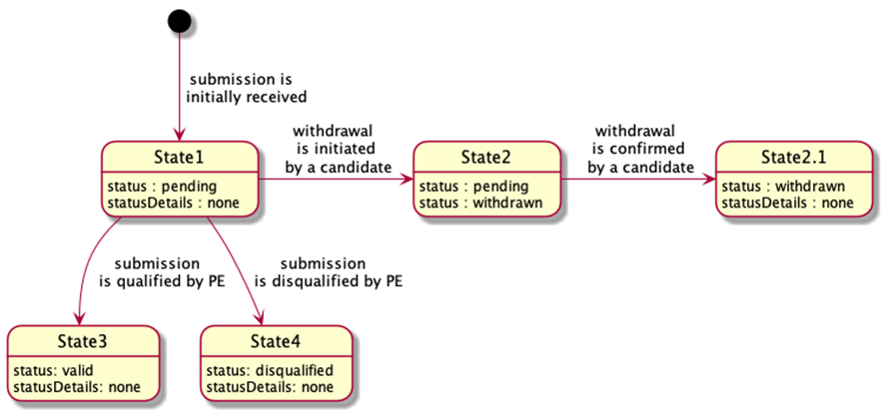

Figure 29 – State-chart diagram for submission of EoIs

All the submissions received remain confidential and closed until the expiration of the period for submission (preQualification.period.endDate). Once the deadline for submissions is reached, no submissions can be received, withdrawn or corrected.

##### State1.1 - Suspension due to non-clarification (active.suspended)

When initiation is suspended, a particular value for tender.statusDetails is used:

|  |
| --- |
| {  "tender":{  "statusDetails": "suspended"  }  } |

Figure 29 – Status of the tender

##### State8.1 - Unsuccessful completion of submission (unsuccessful.lackOfSubmissions)

If not enough submissions were collected during the EoI period, the pre-qualification phase will end unsuccessfully, with no future actions by the CA. The procurement initiation shall be moved to a phase of preparation of a negative notice.

##### Reflection of a negative completion of period for submission

The result of the pre-qualification must be reflected with preQualification.status:

* complete when enough candidates were selected for future invitation to submit a tender;
* unsuccessful when pre-qualification is unsuccessfully completed due to lack of submissions or because all the submissions were disqualified.

|  |
| --- |
| {  "preQualification": {  "status": ""  }  } |

Figure 29 – Status of the preQualification

##### Indication of the unsuccessful outcome of a procurement initiation

* For lots: A negative character of procurement under a specific lot is reflected with lot.status: unsuccessful, when the lot is closed unsuccessfully due to a lack of submissions for pre-qualification or tenders for evaluation, or when all the tenders were rejected;

|  |
| --- |
| {  "lots": [  {  "status": "unsuccessful"  }  ]  } |

Figure 32 – Unsuccessful status at lot level

* For entire initiation: A negative character of a procurement under an entire initiation (procurement process) is reflected with tender.status: unsuccessful, when initiation is closed unsuccessfully due to a lack of submissions for pre-qualification or tenders for evaluation, or where all the tenders were rejected. Details of a negative closure are reflected in tender.statusDetails:
* lackOfSubmissions
* allDisqualified
* lackOfOffers
* allRejected

|  |
| --- |
| {  "tender": {  "status": "unsuccessful",  "statusDetails": ""  }  } |

Figure 33 – Unsuccessful status at tender level

##### State2 - Qualification phase (active.qualification)

##### Initiation of qualification phase

* Disclosure of the submissions: When there are enough submissions, all the submissions are disclosed as a submissions array. All the submissions’ authors are added into parties as organizations with a role: candidate.

|  |
| --- |
| {  "submissions": {  "details": [  {  "id": "1",  "requirementResponses": [  {  "id": "",  "value": "true",  "requirement": {},  "relatedTenderer": {}  },  {  "id": "",  "value": "true",  "requirement": {},  "relatedTenderer": {}  }  ],  "tenderers": [  {}  ]  }  ]  }  } |

Figure 34 – Disculosure of submissions

* Establishment of a period for qualification by the CA: In order to indicate a start of the qualification phase of a procurement process, a start date must be established adding a separate qualificationPeriod object into the preQualification building block, which will reflect a start date of the qualification phase as a system moment:

|  |
| --- |
| {  "submissions": {  "details": [  {  "preQualification": {  "qualificationPeriod": {  "startDate": ""  }  }  } |

Figure 35 – Period for Qualification

* Qualification envelopes: Along with the establishment of preQualification.qualificationPeriod.startDate, a set of qualifications is established against each submission received in order to allow the CA to reflect its decision on each submission. Such objects, based on Qualifications schema, are initially established with status:pending  and statusDetails:awaiting (*State 1* of a qualification object). Since no order is prescribed for the pre-qualification sequence, the CA can evaluate submissions received randomly.

|  |
| --- |
| {  "qualifications": [  {  "id": "",  "status": "pending",  "statusDetails": "awaiting",  "candidates": [],  "relatedSubmission": ""  }  ]  } |

Figure 36 – Status of the Qualification

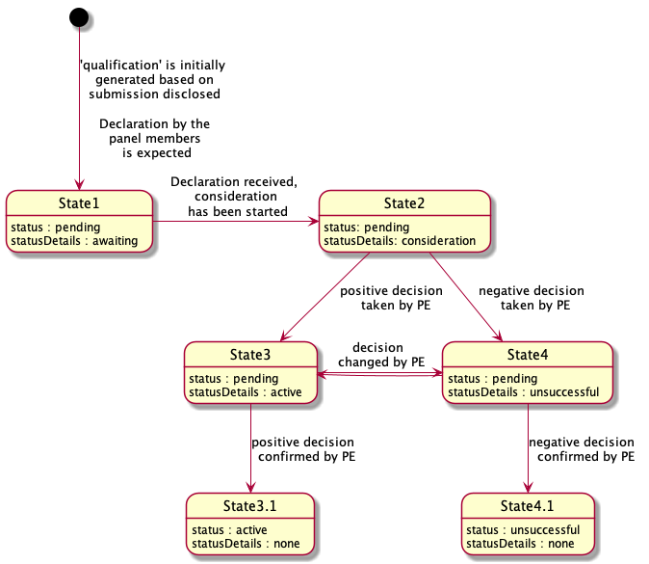

Figure 37 – State-chart diagram for Qualification

##### Declaration of non-conflict of interest

Before starting qualification, each declared member of the Evaluation Panel shall respond with a confirmation of absence of conflict of interest against each candidate from each qualification by sending relevant requirementResponses according to a common flow for declaration.

* Request of declaration: Since the declaration is the same for all members of the Evaluation Panel (either single procurement officers or all the members), it can be designed as a common requirement under specific criteria, related to the organisation appointed as a CA:

|  |
| --- |
| {  "tender": {  "criteria": [  {  "id": "",  "title": "Declaration of absence of conflict of interest and confidentiality",  "relatesTo":"procuringEntity",  "requirementGroups": [  {  "id": "",  "requirements": [  {  "id": "",  "description": "I am aware of Article 24 of Directive 2014/24/EU on public procurement, which states that: ‘The concept of conflicts of interest shall at least cover any situation where staff members of the contracting authority or of a procurement service provider acting on behalf of the contracting authority who are involved in the conduct of the procurement procedure or may influence the outcome of that procedure have, directly or indirectly, a financial, economic or other personal interest which might be perceived to compromise their impartiality and independence in the context of the procurement procedure.’\nto the best of my knowledge and belief I have no conflict of interest with the operators who have submitted a tender for this procurement, including persons or members of a consortium, or with the subcontractors proposed;\nthere are no facts or circumstances, past or present, or that could arise in the foreseeable future, which might call into question my independence in the eyes of any party;\nif I discover during the course of the [project/evaluation] that such a conflict exists or could arise, I will inform the contracting authority without delay;\nI am encouraged to report a situation or risk of conflict of interest as well as any type of wrongdoing or fraud (i.e. whistleblowing), and if I do so, I should not be treated unfairly or be sanctioned;\nI understand that the contracting authority reserves the right to verify this information.",  "dataType": "boolean"  },  {  "id": "",  "description": "I confirm that I will keep all matters entrusted to me confidential. I will not communicate outside the [project team/evaluation committee] any confidential information that is revealed to me or that I have discovered. I will not make any adverse use of information given to me.",  "dataType": "boolean"  }  ]  }  ]  }  ]  }  } |

Figure 38 – Request of declaration

* Declaration: Now each declared member of the Evaluation Panel can respond with a confirmation of absence of conflict of interest against each tenderer from each award (in case of a combined evaluation under single-stage procurement) or each candidate from each qualification (in case of a multi-stage procurement with prior qualification) by sending the relevant requirementResponses.

|  |
| --- |
| {  "awards": [ // "qualifications" for multi-stage procurement with prior qualification  {  "id":"",  "requirementResponses":[  {  "id":"",  "value":true,  "requirement":{  "id":"",  "description":""  },  "relatedTenderer":{  "id":"",  "name":""  },  "responder":{  "id":"",  "name":""  }  },  {  "id":"",  "value":true,  "requirement":{  "id":"",  "description":""  },  "relatedTenderer":{  "id":"",  "name":""  },  "responder":{  "id":"",  "name":""  }  }  ]  }  ]  } |

Figure 39 – Declaration

##### Qualification of submissions

Once all the non-conflict of interest declarations are submitted by Evaluation Committee members, the qualification for review is switched into qualification.statusDetails: consideration (State 2 of a relevant state-chart diagram of a qualification object).

* Consideration: The CA shall update qualification with all the required meta-data. By updating, the CA reflects its decision on each submission received. The CA is allowed to:
  + Add any qualification.documents if needed;
  + add qualification.requirementResponses if any relevant requirements related to the CA within the pre-qualification phase prescribed by criteria is applied;
  + add text qualification.descriptions where any justification is needed;
  + add qualification.date when any decision was taken;
  + add qualification.internalID, if any.
* Indication of a decision: Once consideration of a specific submission is complete and the related qualification is fully updated with all relevant data, the CA shall change the qualification state, reflecting a positive or negative decision in this regard:
  + qualification.statusDetails: active - state 3 of a relevant state-chart diagram of a qualification object. This means the submission is qualified and a candidate(s) will be invited to submit a commercial tender.
  + qualification.statusDetails: unsuccessful - state 4 of a relevant state-chart diagram of a qualification object. This means the submission is disqualified.

|  |
| --- |
| {  "qualifications": [  {  "id": "",  "internalid":"",  "date":"",  "status": "pending",  "statusDetails":"active"  "documents":[],  "requirementResponses":[],  "candidates": [],  "relatedSubmission": ""  },  {  "id": "",  "internalid":"",  "date":"",  "status": "pending",  "statusDetails":"unsuccessful",  "description":"This is why this candidates' submission was rejected"  "documents":[],  "requirementResponses":[],  "candidates": [],  "relatedSubmission": ""  }  ]  } |

Figure 40 – Qualification of submissions

As soon as the CA has completed the qualification and all the submissions received are updated with the relevant meta-data, the CA indicates the end of qualification.

##### State3 - Standstill period for pre-qualification (active.qualificationStandStill)

In this state, no one can take any action except the CA to switch the process to State4 or back to State2. No other actions can be prescribed for the system - all review procedures go offline and the time tracking is up to the CA.

##### Completion of qualification period

If no blockers are indicated during the stand-still period, the CA can initiate the end of the qualificationPeriod and the entire pre-qualification phase. Additional values of the endDate can be added into the preQualification.qualificationPeriod as an indication of pre-qualification completion.

|  |
| --- |
| {  "preQualification": {  "qualificationPeriod": {  "endDate": ""  }  }  } |

Figure 41 – Qualification period

##### Finalization of pre-qualification

* Finalization of the qualifications: All the qualifications shall be moved into relevant final statuses:
  + qualification.status: pending / statusDetails: active → qualification.status: active / statusDetails: none *(state 3 to State 3.1* of a relevant state-chart diagram of a qualification object. Means that the submission is qualified and the candidate(s) is invited to submit a tender);
  + qualification.status: pending / statusDetails: unsuccessful → qualification.status: unsuccessful / statusDetails: none (*state 4 to State 4.1* of a relevant state-chart diagram of a qualification object. Means that the submission is disqualified).
* Finalization of the submissions: All the related submissions are assigned the relevant statuses:
  + submission.status: pending where relevant qualification.status: active → submission.status: valid (*state 1 to State 3* of a relevant state-chart diagram of a submission);
  + submission.status: pending where relevant qualification.status: unsuccessful → submission.status: disqualified (*state 1 to State 4* of a relevant state-chart diagram of a submission).

##### Completion of pre-qualification

The result of the pre-qualification must be reflected with preQualification.status:

* complete where enough candidates were selected for future invitation to submit a tender;
* unsuccessful where pre-qualification is unsuccessfully completed due to a lack of submissions or because all the submissions were disqualified.

|  |
| --- |
| {  "preQualification": {  "status": ""  }  } |

Figure 42 – PreQualification status

##### State8.2 - Unsuccessful completion of pre-qualification (unsuccessful.allDisqualified)

Where all the submissions collected during the EoI period were disqualified, the pre-qualification phase will end unsuccessfully with no future actions by the CA. Procurement initiation shall be moved to a phase of preparation of a negative notice.

##### Completion of qualification period

If no blockers are indicated during the stand-still period, the CA can initiate the end of the qualificationPeriod and the entire pre-qualification phase.

An additional value of endDate is added into preQualification.qualificationPeriod as an indication of pre-qualification completion.

|  |
| --- |
| {  "preQualification": {  "qualificationPeriod": {  "endDate": ""  }  }  } |

Figure 43 –Qualification period

##### Finalisation of pre-qualification

The character of a result of the pre-qualification is reflected with preQualification.status:

* complete where enough candidates were selected for future invitation to submit a tender;
* unsuccessful where pre-qualification is unsuccessfully completed due to a lack of submissions or because all the submissions were disqualified.

|  |
| --- |
| {  "preQualification": {  "status": ""  }  } |

Figure 44 –PreQualification status

##### Indication of the unsuccessful outcome of procurement initiation

* For lots: A negative character of a procurement under a specific lot is reflected with lot.status: unsuccessful where the lot is closed unsuccessfully due to a lack of submissions for pre-qualification or tenders for evaluation, or where all the tenders were rejected.

|  |
| --- |
| {  "lots": [  {  "status": "unsuccessful"  }  ]  } |

Figure 45 –Unsuccessful outcome at lot level

* For entire initiation: A negative character of a procurement under entire initiation (procurement process) is reflected with tender.status: unsuccessful, where initiation is closed unsuccessfully due to a lack of submissions for pre-qualification or tenders for evaluation, or where all the tenders were rejected. Details of a negative closure are reflected in tender.statusDetails:
  + lackOfSubmissions
  + allDisqualified
  + lackOfOffers
  + allRejected

|  |
| --- |
| {  "tender": {  "status": "unsuccessful",  "statusDetails": ""  }  } |

Figure 46 –Unsuccessful outcome at tender level

##### State4 - Evaluation (active.evaluation)

This state means that pre-qualification has been conducted and technical offers requested through a call for proposals sent to the candidates selected by the CA. In case of FAs, such a call shall be implemented via publication of PAC requests either together with the publication of the FA or once pre-qualification is performed, as detailed in section 2.5.5.

In any case, the FA remains in a ‘stand-by’ mode until tenderPeriod expires for all issued PAC requests.

##### State5 - Conclusion of a FA

Once evaluation is performed by the CA for each issued PAC request and a set of purchasing items is identified for each invited candidate, the FA can be concluded. All the purchasing items under the FA, together with any information related to agreed metrics of performance and conditions of execution for each selected EO shall be collected.

To describe and reflect the parties of a concluded FA, a common inclusive contract object shall be added to a FA conclusion record:

|  |
| --- |
| "contracts": [  {  "id": "",  "indernalId": "",  "description": "",  "status": "",  "statusDetails": ""  "period": {  "startDate": "",  "endDate": ""  },  "suppliers": [],  "isFrameworkOrDynamic": false  }  ] |

Figure 47 –Conclusion of a FA

Such an object reflects:

* Requisites of the FA;
* period and duration;
* list of selected EOs.

To reflect the scope of the FA together with all metrics agreed by the parties, a set of framework contracts concluded as a result of PAC requests shall be listed using a relatedProcesses array:

|  |
| --- |
| "contracts": [  {  "relatedProcesses":[  {  "id":"",  "relationship":[  "x_frameworkContract"  ],  "scheme":"ocid",  "identifier":"",  "uri":""  }  ]  }  ] |

Figure 48 –Scope of the FA

##### State6 - Completion of a procedure

##### Indication of the successful outcome of procurement initiation

* For lots: Positive character of a procurement under a specific lot must be reflected with lot.status: complete.

|  |
| --- |
| {  "lots": [  {  "status": "complete"  }  ]  } |

Figure 49 –Successful outcome at lot level

* For entire initiation: Positive character of a procurement under the entire initiation (procurement process) must be reflected with tender.status: complete.

|  |
| --- |
| {  "tender": {  "status": "complete"  }  } |

Figure 50 –Successful outcome at tender level

### Pre-award catalogue request

A PAC request under a FA can be issued when:

* All terms and conditions of the procurement are established with the conclusion of the FA, that is, when the CA has enough information from the beginning of the process. In this case, the issuing of the PAC goes together with the publication of the CN of the FA;
* the CA doesn't have enough information or is not willing to disseminate the details before the conclusion of the FA. In this case, the issuing of the PAC goes right after the pre-qualification phase, once the EOs have already been selected.

##### State-chart diagram

The sequence of a stages applicable for a PAC request is the following:

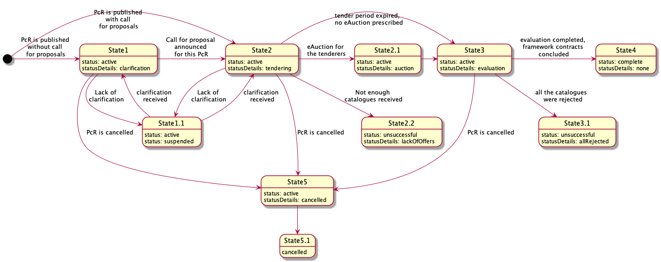

Figure 51 – State-chart diagram for a PAC request

##### OCDS dataset

##### Issuing of a PAC request

The PAC request within a FA shall include:

* List of products category determined for this request;
* minimum technical specification or a specific nomenclature, where applicable;
* lots, where applicable;
* fixed and non-fixed terms and conditions;
* awarding mechanisms and evaluation criteria and techniques.

##### State1 - Clarification (active.clarification)

In the case of publication of a PAC request (for informational purposes and for discussion but without call for proposals), the CA shall initiate a period for clarifications for all the interested EOs.

Call for enquiries

In order to indicate a start of the explanatory phase of a procurement process, the CA shall establish a start date as an enquiry session. Such an indication shall be done by adding a separate enquiryPeriod object into the tender building block, which will reflect the end date indicated by the CA and its start date will reflect the moment of initiation of the explanatory phase in the system:

|  |
| --- |
| {  "tender": {  "enquiryPeriod": {  "startDate": "",  "endDate": ""  }  }  } |

Figure 52 – Enquiry period

##### State2 - Tendering (active.tendering)

Either after the clarification phase (State1) or together with the publication of the PAC request, the CA shall initiate a period for submission of the PAC by either any interested EO or invited candidates.

Call for proposals

In order to indicate the start of the tendering phase of a procurement process, the CA shall establish a start date for the tendering period during which interested EOs will be able to submit their tenders. This shall be done by adding a separate tenderPeriod object into the tender building block which will reflect the end date indicated by the CA and its start date will reflected the moment of initiation of the tendering phase in the system:

|  |
| --- |
| {  "tender": {  "tenderPeriod": {  "startDate": "",  "endDate": ""  }  }  } |

Figure 53 – Tender period

|  |
| --- |
| When the call for proposals is to be published together with the publication of a PAC request, call for enquiries is supposed to be included into the same period of time but as a separate object as described above. |

Tendering

Each invited EO is allowed to submit a tender within the given tender.tenderPeriod indicated with the call for proposals. Each tender must be based on a bids schema and shall fulfill all the requirements prescribed by the criteria related to items or lots with a relevant list of the responses provided by the EO (confirmative or quantifiable according to available values by applied PQQ) by providing an array of requirementResponses.

|  |
| --- |
| Having a set of requirements predefined by the CA and a number of values available for each requirement, EOs shall specify a value for each requirement and fulfil general corporate profiles’ data as requested by the CA or required by the Legal Framework of a particular jurisdiction. |

Thus, each offer includes:

1. An organisation profile according to the extended ‘organisation’ model (or a reference on such profile previously sent while submitting an EoI, in the case of two-stage procedures);
2. set of documents of the tender, specified with relevant types of documents for their future splitting into the different "envelopes";
3. absolute financial value of the tender;
4. decomposed array of unit prices (when requested by the CA);
5. set of required responses according to criteria specified by the CA within the CN:

* Responses on requirements regarding the nature of the subject-matter of procurement;
* responses on requirements regarding the nature of the delivery and post-delivery.

|  |
| --- |
| {  "bid": {  "id": "",  "status": "",  "relatedLots": [],  "tenderers":[],  "items": [  {  "id": "",  "description": "",  "quantity": "",  "unit": {},  "relatedLot":""  }  ],  "requirementResponses":[]  }  } |

Figure 54 – Bid information

All the tenders collected remain confidential and closed until the expiration of the tendering period, tender.tenderPeriod.endDate. After tender.tenderPeriod.endDate, no tenders can be received, withdrawn or corrected.

##### State2.2 - Unsuccessful completion of tendering (unsuccessful.lackOfOffers)

Where not enough bids were collected during the tendering period for all lots, the evaluation phase will end in an unsuccessful way with no future actions by the CA. Procurement initiation shall be moved to a phase of preparation of a negative notice.

Indication of the unsuccessful outcome of procurement initiation

* For lots

A negative character of procurement under a specific lot is reflected with lot.status: unsuccessful, where the lot is closed unsuccessfully due to a lack of submissions for pre-qualification or tenders for evaluation, or where all the tenders were rejected.

|  |
| --- |
| {    "lots": [      {        "status": "unsuccessful"      }    ]  } |

Figure 55 – Unsuccessful lot

* For entire initiation (tender)

Where all the lots are unsuccessful, the entire procurement initiation goes to State8.3, which is common to any procurement method and described in a separate document (the API guide for NEPPs).

A negative character of a procurement under an entire initiation (procurement process) is reflected with tender.status: unsuccessful, where initiation is closed unsuccessfully due to a lack of submissions for pre-qualification or tenders for evaluation, or where all the tenders were rejected. Details of a negative closure are reflected in tender.statusDetails

* lackOfSubmissions
* allDisqualified
* lackOfOffers
* allRejected

|  |
| --- |
| {    "tender": {      "status": "unsuccessful",  "statusDetails": ""    }  } |

Figure 56 – Unsuccessful tender

##### State3 - Evaluation (active.evaluation)

Initiation of evaluation phase

* Disclosure of the proposals

Where enough bids are received, all the tenders are disclosed as a bids array. All the authors (bid.tenderers) are updated into parties as an organizations with a role: tenderer.

|  |
| --- |
| {  "bids": {  "details":[  {  "id": "",  "status": "pending",  "statusDetails":""  "relatedLots": [],  "tenderers":[],  "items": [  {  "id": "",  "description": "",  "quantity": "",  "unit": {},  "relatedLot":""  }  ],  "requirementResponses":[]  }  }  ]  } |

Figure 57 – Disclosure of bids

* Establishment of a period for evaluation

A separate object awardPeriod is added into a tender block where the specific startDate for awarding is determined automatically. Such block is based on a Period schema

|  |
| --- |
| {  "tender": {  "awardPeriod": {  "startDate": ""  }  }  } |

Figure 58 – Award period

* Evaluation envelopes

Along with tender.awardPeriod.startDate, a set of all tenders received during prior tendering phase must be disclosed using a bids array according to the relevant schema. All the bids authors (referring to final offers) must be updated into parties with a role: tenderer. Such objects are based on the Awards schema and are initially established with status:pending and statusDetails:none. All the submissions authors (referring to EoI or ESPD or other related documentation aimed at the qualification of the EO) must be added into parties as an organizations with a role: candidate.

|  |
| --- |
| {  "awards": [  {  "id": "",  "status": "pending",  "suppliers": [],  "relatedLots": [],  "relatedBid": ""  }  ]  } |

Figure 59 – Evaluation

* Disclosure of the enquirers

Together with the initiation of the evaluation phase, all the enquirers (tender.enquiries[*].author) must be reflected into a parties array with role: enquirer, once the tender.enquiryPeriod.endDate is achieved.

Initial ranking on award criteria

Depending on tender.awardCriteria and tenderAwardCriteriaDetails, an initial automated ranking can or cannot be done on:

|  |  |  |  |  |
| --- | --- | --- | --- | --- |
| **awardCriteriaDetatils / awardCriteria** | **priceOnly** | **costOnly** | **qualityOnly** | **ratedCriteria** |
| automated | bid.value | bid.requirementResponses * lot.value | bid.requirementResponses * 1 | bid.requirementResponses * bid.value |
| manual |  |  |  |  |

Table 18 – Award criteria

As shown in the table above, automated ranking can be undertaken automatically using a set of criteria and the relevant conversions applied by the CA for each available value of each applied requirement and published in a CN, on one hand; and the bid.requirementResponses  submitted by each EO against published criteria on the other hand. These two data-sets allow the normalised value for each bid based on the same approach.

* Normalised price

Where normalised price must be calculated, the following formula is applied for each tender in order to identify which one is most suitable by normalised price:

*Pn = P * C1 * C2 * ... Cn*

where:

* + Pn - value of normalised price
  + P - basic price taken from bid.value or lot.value  or equal to '1' depending on awardCriteria
  + C1 ... Cn - values of the coefficients to be applied (related with values of requirements, available for EO and indicated in requirementResponses)
* Ranking approach
  + Where awardCriteria: priceOnly, only bid.value is to be compared in order to identify the most suitable tender - cheapest goes first;
  + where awardCriteria: costOnly, assumption is that all the tenderers have the bid.value equal to lot.value. This means that the normalised price needs to be calculated for each bid  received, based on an estimated value lot.value - cheapest goes first;
  + where awardCriteria: qualityOnly, assumption is that the price doesn't matter and the only valuable part of the tender is the quality, meaning the set of values of criteria, selected by the EO while submitting a tender. This means that the normalised price needs to be calculated for each bid  received, based on '1';
  + where awardCriteria: ratedCriteria, assumption is that both price and quality matter. This means that the normalised price needs to be calculated for each bid  received based on 'bid.value'.

Where automated ranking is the case, all the awards are ranked into order for evaluation and the first award (most suitable according to the prescribed evaluation function) will be switched to the next state ‘available for evaluation’ by the CA.

|  |
| --- |
| Depending on previously established or not established eligibility check, this state may be:   * award.statusDetails: consideration - where eligibility check took place previously; * award.statusDetails: awaiting - where eligibility check was not conducted previously by the CA. |

Consideraton

* Evauation

To evaluate the award, the CA shall update it with all the required meta-data. In these updates, the CA is allowed to:

* + Add any documents  if needed;
  + Add requirementResponses if there are any relevant requirements  related to the CA within the evaluation phase prescribed by tender.criteria;
  + Add text descriptions  where any justification is needed;
  + Add date  when the decision was taken;
  + Add internalID if any.
* Indication of a decision

Once the evaluation of a specific tender is complete and the related award is fully updated with all relevant data, the CA shall switch the award to one of the states, reflecting a positive or negative decision:

* award.statusDetails: active - means the related bid is selected as a winning tender to be awarded;
* award.statusDetails: unsuccessful - means the related bid is rejected.

|  |
| --- |
| {  "awards": [  {  "id": "",  "description": "",  "status": "pending",  "date": "active",  "suppliers": [],  "relatedLots": [],  "relatedBid": "",  "documents": [],  "requirementResponses": [],  "indernalId": ""  }  ]  } |

Figure 60 – Awards

As soon as the CA has completed the evaluation and the winning candidates for a particular lot are identified or all the proposals under this lot are rejected, the CA indicates the end of evaluation for the lot by publishing an intention to award a contract (award decision).

Award decision

To reflect a decision regarding each specific lot and the proposal selected to be awarded with a contract (award.statusDetails:active), the CA prepares a Notice on Award Decision. This data-entity is included in a contracts array.

Since it is a stand-still period for evaluation, initially these contracts are established with a status: pending and statusDetails which reflects a decisions' character:

* contract.statusDetails: active where the decision regarding the lot is positive (winner is identified);
* contract.statusDetails: unsuccessful where the decision regarding the lot is negative (all the tenders were rejected).

|  |
| --- |
| {    "contracts": [      {        "id": "",  "date": "",  "awardId": "",  "status": "pending",  "statusDetails": "awaiting",      }    ]  } |

Figure 61 – Contracts

Stand-still period

In this state, no one can take any actions except the CA, who switches the process to State4 or back to State2. No other actions can be prescribed for the system - all review procedures go offline, and the time tracking is up to the CA.

Cancellation of the award decision

To reflect a decision to cancel a specific award decision taken previously under a particular lot, the CA shall switch the relevant contract object into contract.status: cancelled

|  |
| --- |
| {    "contracts": [      {        "status": "cancelled"      }    ]  } |

Figure 62 – Contract status

Confirmation of the award decisions

If no blockers indicated during stand-still period, the CA can initiate contract preparation for the awarded lot or finalization of an unsuccessful output of a lot where all the proposals were rejected during the evaluation phase.

* Confirmation of a negative award decision

Confirmation of a negative award decision requires switching the relevant contract object to final status:unsuccessful, with a parallel indication of the reason for a negative outcome as a statusDetails:

|  |
| --- |
| {  "contracts" : [  {  "id":"",  "awardId":"",  "status":"unsuccessful",  "statusDetails": "allOffersRejected"  }  ]  } |

Figure 63 – Unsuccessful contract

* Confirmation of a positive award decision

Confirmation of a positive decision requires reflecting the subsequent contract initiation into a relevant contract object by indicating statusDetails, provided that the object remains intermediate status: pending

|  |
| --- |
| {  "contracts" : [  {  "id":"",  "awardId":"",  "status":"pending",  "statusDetails": "contractPreparation"  }  ]  } |

Figure 64 – Status “Pending”

Contract initiation

To describe and reflect the scope of a contract to be concluded on a positive award decision, a parallel data-stream will be initiated. This stream is a separate OCDS-record where all the information related to future contracts is collected from a current procurement process. In order to establish the relation with this parallel stream, the relevant contract reflects a positive award decision and shall be extended with a relatedProcess.relationship: [x_contracting]:

|  |
| --- |
| {  "contracts" : [  {  "id":"",  "awardId":"",  "status":"pending",  "statusDetails": "contractPreparation",  "relatedProcesses": [  {  "id": "",  "relationship": [  "x_contracting"  ],  "scheme": "ocid"  }  ]  }  ]  } |

Figure 65 – Contract initiation

Contract preparation and activation

According to a common flow of [preparation of a contract to be concluded](https://ustudio.atlassian.net/wiki/spaces/VISION/pages/733511845/Preparation+of+a+Contract+to+be+concluded)

##### State3.1 - Unsuccessful completion of evaluation (unsuccessful.lackOfOffers)

Where all the bids collected during the period of tendering were rejected, the evaluation phase will end unsuccessfully with no future actions by the CA.

Completion of the evaluation phase

The completion of the evaluation phase flow is common to any procurement method and described in a separate document (the API guide for NEPPs).

Indication of the unsuccessful outcome of procurement initiation

* For lots

A negative character of procurement under a specific lot is reflected with lot.status: unsuccessful, where the lot is closed unsuccessfully due to a lack of submissions for pre-qualification or tenders for evaluation, or where all the tenders were rejected.

|  |
| --- |
| {    "lots": [      {        "status": "unsuccessful"      }    ]  } |

Figure 66 – Unsuccessful lot

* For entire initiation (tender)

A negative character of a procurement under the entire initiation (procurement process) is reflected with tender.status: unsuccessful, where the initiation is closed in a negative way due to a lack of submissions for pre-qualification or tenders for evaluation, or where all the tenders were rejected. The details of a negative closure are reflected in tender.statusDetails.

* + lackOfSubmissions
  + allDisqualified
  + lackOfOffers
  + allRejected

|  |
| --- |
| {    "tender": {      "status": "unsuccessful",  "statusDetails": ""    }  } |

Figure 67 – Unsuccessful tender

##### State4 - Completion of procedure

Indication of the successful outcome of procurement initiation

* For lots

A positive character of a procurement under a specific lot is reflected with lot.status: complete

|  |
| --- |
| {    "lots": [      {      "status": "complete"      }    ]  } |

Figure 68 – Successful lot

* For entire process

A positive character of a procurement under an entire initiation (procurement process) is reflected with tender.status: complete.

|  |
| --- |
| {    "tender": {      "status": "complete"    }  } |

Figure 69 – Successful tender

1. [https://ebrd.huddle.net/workspace/36712039/files/#/83312462](https://ebrd.huddle.net/workspace/36712039/files/%23/83312462)
2. <https://app.lucidchart.com/publicSegments/view/b09729c6-cc4d-44ce-be4d-2afbe2e96195/image.png>
3. <https://cawemo.com/share/4936b1c7-4467-432d-aee6-1b2cc8b3be03>
4. <https://app.lucidchart.com/publicSegments/view/5c214c2e-a030-4783-bace-a9731cc29018/image.png>
5. <https://cawemo.com/share/23f00821-b867-413d-b62c-eb482f34a1d6>
6. <https://cawemo.com/share/1ae8009c-d717-4ad0-aabc-f4b87337b925>